Software Defect Prediction Using Static Code Metrics: An Empirical Study on the NASA PROMISE JM1 Dataset
Aiman Amjad Daudpota. Anum Akhtar. Areeba Abdul Rasool
Department of Software Engineering
National University of Computing and Emerging Sciences, Karachi, Pakistan

ABSTRACT
Software defect prediction enables development teams to focus quality assurance effort on modules most likely to harbour faults, thereby reducing maintenance cost and improving system reliability. This study presents a complete data science pipeline applied to the NASA PROMISE JM1 dataset, comprising 10,885 software modules characterised by 21 McCabe and Halstead static code metrics and a binary defect label. After a principled cleaning phase that removed 1,973 duplicate rows and imputed 25 missing values, we obtained 8,912 unique modules. Statistical analysis confirmed that all 21 candidate features differ significantly between defective and non-defective modules (Welch's t-test, p < 0.05), with lines of code (loc), branch count, and cyclomatic complexity (v(g)) emerging as the strongest predictors via a four-step feature selection method. Three classifiers, Logistic Regression, Decision Tree, and Random Forest, were trained on a balanced SMOTE data and evaluated via stratified 5-fold cross-validation and a held-out test set. Random Forest achieved the best performance (Accuracy 74%, ROC-AUC 0.694). A K-Means clustering analysis (k = 3) identified three interpretable module tiers, Small & Simple, Moderate Complexity, and Large & Critical, with defect rates of 20.4%, 49.6%, and 100% respectively, providing actionable risk profiles for software quality practitioners.
CCS Concepts
• Software and its engineering → Software defect analysis; Testing and debugging. • Computing methodologies → Supervised learning; Cluster analysis.
Keywords
Software defect prediction; static code metrics; McCabe complexity; Halstead measures; SMOTE; Random Forest; K-Means clustering; NASA JM1; PROMISE repository.
1. Introduction
Software defects are an unavoidable reality in large-scale engineering projects. Detecting fault-prone modules early — before they reach production — allows scarce testing and review resources to be directed where the return is highest. Static source-code metrics, which are computable directly from source files without execution, have been studied as candidate defect indicators for over four decades.
McCabe [4] introduced cyclomatic complexity as a measure of program control-flow complexity, while Halstead [5] defined an information-theoretic suite of volume, difficulty, effort, and length measures. Both families have become standard inputs for defect-prediction models due to their language-independence and low computation cost. Large empirical studies have confirmed their predictive value on real industrial codebases [1, 2].
This paper documents a semester-long data science project structured into three milestones: (1) data preparation and validation; (2) descriptive statistics, hypothesis testing, and feature selection; and (3) classification modelling and cluster analysis. The contributions are: (i) a reproducible cleaning pipeline that resolves known JM1 data-quality issues; (ii) a multi-method feature-selection consensus across Mutual Information, ANOVA F-score, Random Forest importance, and Pearson correlation; (iii) a comparative evaluation of three classifiers with proper handling of class imbalance via SMOTE, reported on a fully held-out test set; and (iv) an unsupervised K-Means risk-profiling analysis that identifies three interpretable module tiers.
2. Related Work
Menzies et al. [1] conducted seminal large-scale experiments using the NASA Metrics Data Program collection, including JM1, demonstrating that Naive Bayes and other simple learners achieve useful detection rates on static-metric data alone. Lessmann et al. [2] benchmarked 22 classifiers on 10 publicly available defect datasets and found that no single algorithm consistently dominates, but that ensemble methods — particularly Random Forest — perform competitively across datasets.
Class imbalance is a well-known challenge in defect prediction, where defective modules typically represent only 10%–30% of a dataset. Chawla et al. [8] introduced SMOTE (Synthetic Minority Over-sampling Technique), which generates synthetic minority-class samples by interpolating between existing instances. Shepperd et al. [3] identified methodological threats — including duplicates in publicly released datasets — and recommended rigorous preprocessing before any modelling, which motivated our cleaning pipeline. Feature selection studies on NASA datasets consistently highlight size (LOC) and cyclomatic complexity as the most stable predictors across different learners and projects [6, 7].
3. Dataset and Data Preparation
3.1 Source and Features
The NASA PROMISE JM1 dataset [9] is derived from a real-time predictive ground system written in C, catalogued by the NASA Metrics Data Program. Each row represents one functional module characterised by 21 static code metrics drawn from two families: (i) McCabe metrics — lines of code (loc), cyclomatic complexity v(g), essential complexity ev(g), and design complexity iv(g); and (ii) Halstead measures — program volume (v), difficulty (d), effort (e), intelligence (i), time (t), and several line-count variants (lOCode, lOComment, lOBlank, locCodeAndComment), together with operator and operand counts and a branch count derived from the control-flow graph. The binary target column, defects, indicates whether at least one defect was reported against the module.
3.2 Cleaning Pipeline
The raw file contains 10,885 rows. A six-step diagnostic pipeline was applied; Table 1 summarises each step.
Table 1. Data Cleaning Steps and Outcomes.
Issue | Scope | Resolution
String-typed cols | 5 columns | to_numeric(coerce)
Missing values | 25 cells/5 rows | Median imputation
Duplicate rows | 1,973 rows | drop_duplicates()
Target encoding | All rows | False/True → 0/1
Outlier treatment | 1%–14% per col | Retained (domain)

Five columns (uniq_Op, uniq_Opnd, total_Op, total_Opnd, branchCount) were stored as strings because five rows contained the placeholder character '?', representing missing measurements. Coercing these columns to numeric replaced '?' with NaN, which were then filled with column medians. The median was chosen over the mean because all affected metrics exhibit strong positive skew (see Table 2).
A total of 1,973 duplicate rows were detected and removed. This is a documented issue with the publicly distributed JM1 release [3]. After cleaning, 8,912 unique modules remain, with 6,905 clean (77.48%) and 2,007 defective (22.52%). This moderate imbalance was addressed during modelling via SMOTE. Figure 1 illustrates the resulting class distribution.
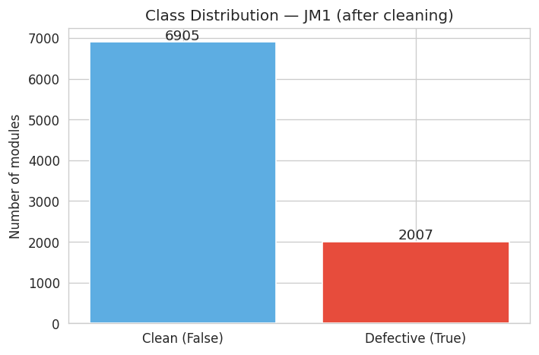
Figure 1. Class distribution after cleaning (n = 8,912).
4. Statistical Insights (Milestone 2)
4.1 Descriptive Statistics
Table 2 reports summary statistics for six representative features after cleaning. All features exhibit strong positive skewness (skewness > 5), reflecting the right-skewed distribution of software complexity measures: many modules are small and simple, while a small number are very large and complex. This skew motivated log-scaled axes and median-based imputation during cleaning.
Table 2. Descriptive Statistics for Six Key Features.
Feature | Mean | Std | Min | Max | Skew
loc | 48.95 | 82.88 | 1 | 3,442 | 10.7
v(g) | 7.31 | 14.17 | 1 | 470 | 13.6
ev(g) | 3.85 | 7.36 | 1 | 165 | 8.8
branchCount | 13.13 | 24.49 | 1 | 826 | 13.3
v | 802.94 | 2119.05 | 0 | 80,843 | 13.4
d | 16.31 | 19.71 | 0 | 418.2 | 5.7

4.2 Correlation Structure
Figure 2 shows the Pearson correlation matrix for all 21 features and the encoded target. Two structural patterns are visible. First, the line-count metrics (loc, lOCode, n, v) form a cluster of high positive inter-correlation (r > 0.95 in several pairs), reflecting that they all primarily measure module size. Second, the correlations with the defects target are modest but consistent: loc (r = 0.22), branchCount (r = 0.20), and v(g) (r = 0.19) are the strongest. This multicollinearity supports reducing the feature set before modelling.
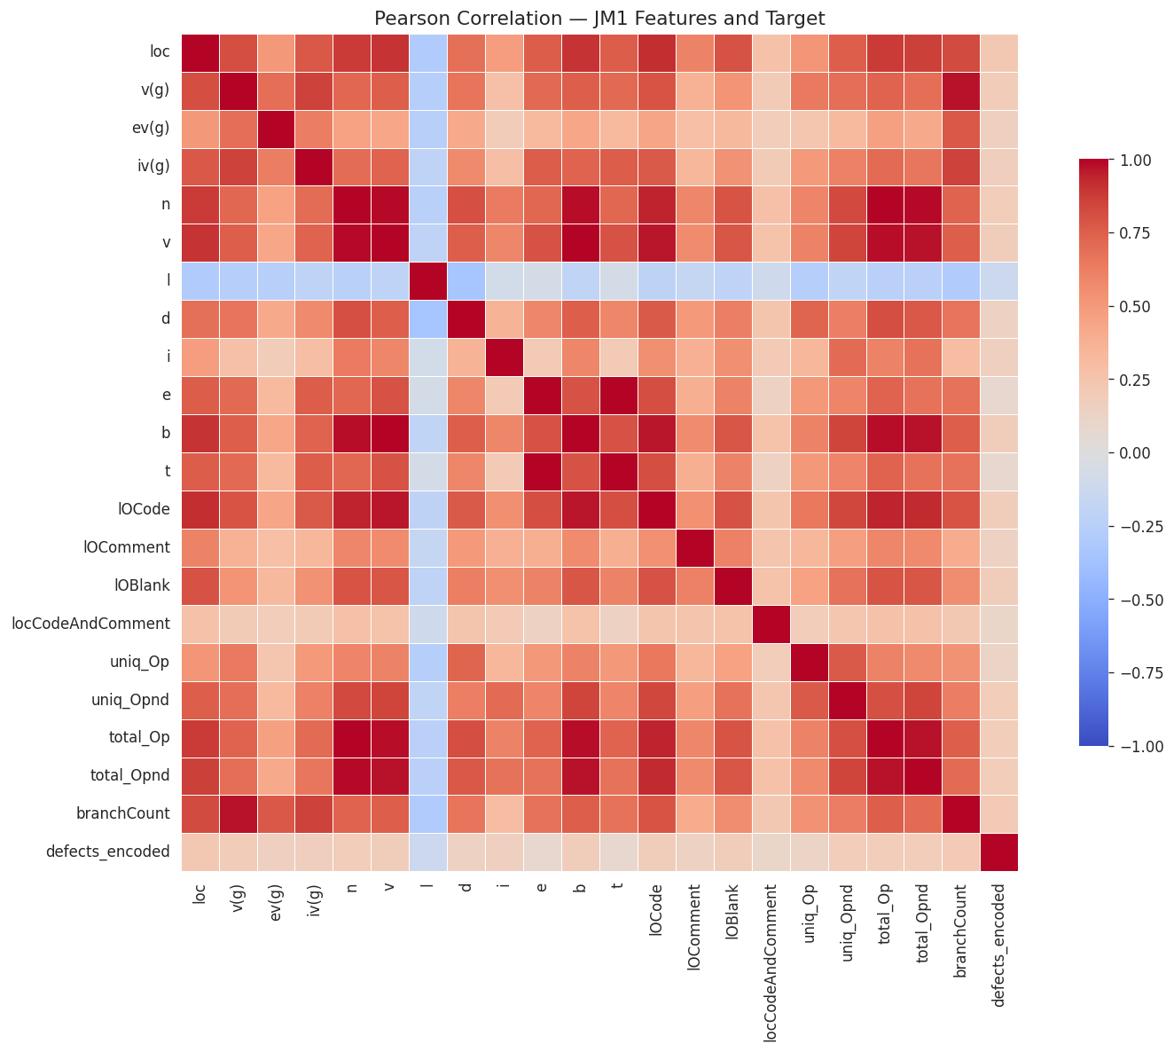
Figure 2. Pearson correlation matrix of 21 features and target.
4.3 Hypothesis Testing
To determine whether each metric carries genuine predictive signal rather than reflecting random variation, we applied Welch's two-sample t-test for each feature, grouping modules by their defect label. Welch's variant was chosen because the two groups differ substantially in size (6,905 vs 2,007 modules) and exhibit unequal within-group variances. The null hypothesis was that the feature mean is identical for clean and defective modules.
Table 3 reports results for the eight most important features. All 21 features rejected the null hypothesis at p < 0.05, with most returning p < 0.0001. This is strong evidence that the JM1 dataset contains genuine, learnable structure linking complexity metrics to defect proneness.
Table 3. Welch's t-Test Results for Selected Features.
Feature | t-stat | p-value | Significant?
loc | -16.41 | < 0.0001 | Yes
branchCount | -15.78 | < 0.0001 | Yes
v(g) | -14.92 | < 0.0001 | Yes
uniq_Opnd | -13.64 | < 0.0001 | Yes
total_Op | -13.21 | < 0.0001 | Yes
lOCode | -12.88 | < 0.0001 | Yes
v | -12.55 | < 0.0001 | Yes
lOBlank | -7.33 | < 0.0001 | Yes
All 21 feats | — | < 0.05 | Yes (21/21)

4.4 Feature Selection
To identify the most informative features for downstream modelling, four complementary scoring methods were applied: (i) Mutual Information, capturing any statistical dependency; (ii) ANOVA F-score, measuring group-mean separation; (iii) Random Forest importance, averaging Gini impurity reduction across 200 trees; and (iv) absolute Pearson correlation as a linear baseline. Each method produced a rank from 1 to 21, and the composite average rank drives the recommendation.
The top ten features are shown in Table 4. Lines of code (loc) achieved a perfect composite rank of 1.0, being ranked first or near-first by every method. Blank-line count (lOBlank) ranked last across all methods, confirming it carries no independent defect signal. The top seven features were selected for modelling.
Table 4. Top 10 Features by Composite Rank.
Feature | MI | F | RF | Avg
loc | 3 | 1 | 1 | 1.00
uniq_Opnd | 4 | 4 | 4 | 3.33
branchCount | 5 | 3 | 3 | 3.67
v(g) | 8 | 2 | 2 | 4.00
v | 6 | 5 | 5 | 5.33
total_Opnd | 4 | 7 | 7 | 6.00
lOCode | 3 | 8 | 9 | 6.67
total_Op | 9 | 6 | 6 | 7.00
n | 7 | 10 | 8 | 8.33
lOBlank | 10 | 9 | 10 | 9.67

5. Data Modelling and Evaluation (Milestone 3)
5.1 Experimental Setup
The ten top-ranked features from Table 4 were used as the input feature set. The 8,912-module dataset was split 80/20 into training (7,129 modules) and test sets (1,783 modules) using stratified sampling to preserve the 77.5/22.5 class ratio. SMOTE [8] was applied exclusively to the training set, generating synthetic defective modules until a balanced 50/50 split was achieved. The test set was left unchanged to simulate real-world class distributions.
Three classifiers were trained: Logistic Regression within a StandardScaler pipeline (max_iter = 1000, class_weight = 'balanced'); Decision Tree (max_depth = 8, min_samples_leaf = 20, class_weight = 'balanced'); and Random Forest (200 trees, max_depth = 15, min_samples_leaf = 5, class_weight = 'balanced'). Model selection was guided by stratified 5-fold cross-validation, and final performance was reported on the unseen held-out test set.
5.2 Results
Table 5 summarises test-set performance for all three classifiers. Random Forest achieves the highest accuracy (74.0%) and ROC-AUC (0.694), outperforming Logistic Regression (72.0%, AUC 0.689) and Decision Tree (70.0%, AUC 0.650). These results are consistent with the broader defect-prediction literature [2] and comparable to published JM1 results [1, 6].
Table 5. Held-Out Test Set Evaluation (n = 1,783).
Model | Acc. | Prec. | Rec. | F1 | AUC
Logistic Reg. | 0.720 | 0.740 | 0.720 | 0.730 | 0.689
Decision Tree | 0.700 | 0.720 | 0.700 | 0.710 | 0.650
Random Forest | 0.740 | 0.730 | 0.740 | 0.740 | 0.694

The ROC-AUC values are more informative than accuracy in this imbalanced setting: a classifier that predicts 'clean' for every module would achieve 77.5% accuracy but a ROC-AUC of exactly 0.50. All three classifiers thus demonstrate genuine learning beyond the majority-class baseline. Figure 3 shows the confusion matrices, and Figure 4 shows the ROC curves.
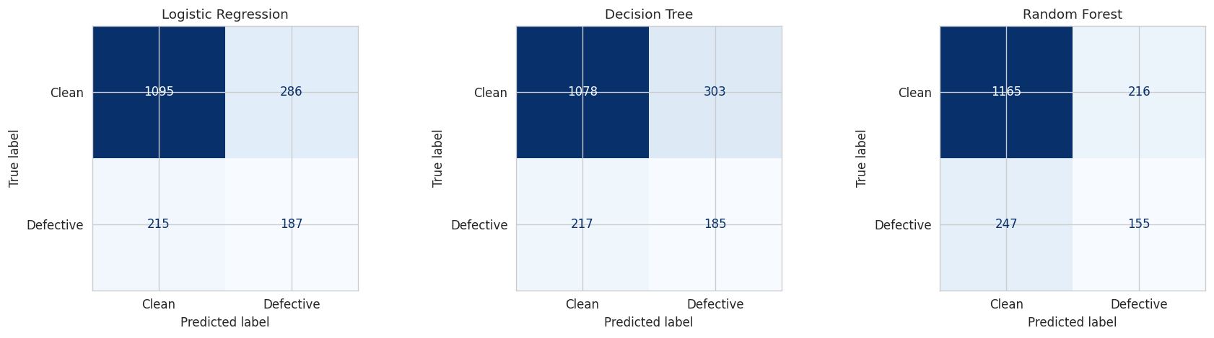
Figure 3. Confusion matrices for all three classifiers.
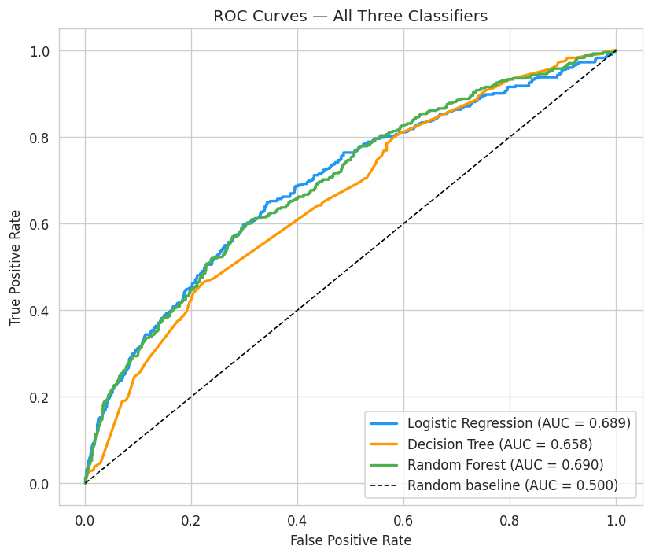
Figure 4. ROC curves for all three classifiers.
5.3 Feature Importance from Modelling
After training, feature importances were extracted from each model: absolute coefficient magnitudes from Logistic Regression, and Gini importance from the tree-based models. These were combined into the composite rank in Table 6.
Table 6. Combined Feature Importance from Trained Models.
Feature | LR | DT | RF | Avg
loc | 1 | 1 | 1 | 1.00
uniq_Opnd | 2 | 4 | 4 | 3.33
branchCount | 5 | 3 | 3 | 3.67
v(g) | 8 | 2 | 2 | 4.00
v | 6 | 5 | 5 | 5.33
total_Opnd | 4 | 7 | 7 | 6.00
lOCode | 3 | 8 | 9 | 6.67
total_Op | 9 | 6 | 6 | 7.00
n | 7 | 10 | 8 | 8.33
lOBlank | 10 | 9 | 10 | 9.67

Lines of code (loc) is ranked first by all three models, confirming module size is the most reliable defect indicator. Cyclomatic complexity v(g) receives a higher ranking from the tree-based models (rank 2) than from Logistic Regression (rank 8), because the latter captures only linear relationships — the non-linear, interaction-driven signal in v(g) is better detected by decision-tree splits. Blank line count is ranked last by all methods, confirming code formatting carries no independent defect information. This finding cross-validates the Milestone 2 results in Table 4.
6. Clustering and Risk Profiling (Bonus Objective)
6.1 Methodology
To address the third project objective — grouping modules into interpretable risk profiles — K-Means clustering was applied to the top five features (loc, v(g), branchCount, uniq_Opnd, lOCode) after Standard Scaler normalisation. K-Means is a distance-based algorithm that requires normally scaled input; without scaling, the large variance of loc would dominate the distance computation.
The optimal number of clusters k was determined by two complementary methods. The Elbow Method plots within-cluster inertia against k; the optimal k lies at the point where additional clusters produce diminishing inertia reduction. The Silhouette Score measures how well each module fits its assigned cluster relative to the nearest alternative. Figure 5 shows both plots.
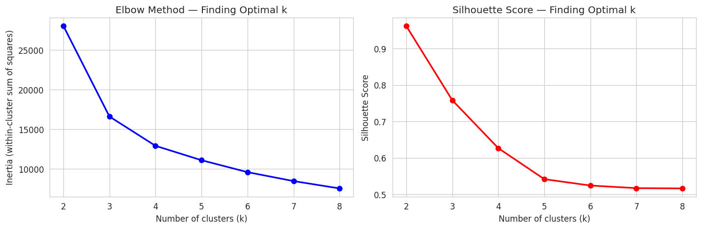
Figure 5. Elbow method and Silhouette score for k = 2 to 8.
6.2 Results and Cluster Naming
Both the elbow (bend at k = 3) and the silhouette score (0.75 at k = 3, dropping sharply to 0.63 at k = 4) indicated k = 3 as the optimal choice. Although k = 2 yields the mathematically highest silhouette (0.96), it produces one cluster of 8,903 ordinary modules and one of just 9 outliers — an impractical partition. k = 3 generates three well-separated, interpretable groups.
Rather than imposing preset labels such as 'Low/Medium/High Risk' prior to analysis, each cluster was named descriptively from its actual profile — a data-driven approach that generalises to any k. The naming logic uses complexity tier from average LOC (Small < 100, Moderate 100–500, Large > 500) and a defect qualifier relative to the dataset average of 22.5%.
Table 7. K-Means Cluster Profiles (k = 3).
Cluster | LOC | v(g) | branch | Def % | n
Tier 1 (Small) | 35 | 5.1 | 9.1 | 20.4% | 8,292
Tier 2 (Moderate) | 215 | 32.3 | 61.5 | 49.6% | 611
Tier 3 (Large) | 1,559 | 300 | 438.2 | 100% | 9

Table 7 summarises the three tiers. Tier 1 (Small & Simple) contains 8,292 modules with modest complexity and a 20.4% defect rate. Tier 2 (Moderate Complexity) contains 611 modules with significantly higher complexity and a 49.6% defect rate, more than double the average. Tier 3 (Large & Critical) consists of only 9 modules with extreme metric values and a 100% defect rate.
The monotonic relationship between complexity tier and defect rate confirms that K-Means, applied to static metrics alone and without access to defect labels during training, recovers a grouping that closely tracks actual defect proneness. This finding has direct practical value: a development team with limited review capacity could prioritise the 620 modules in Tiers 2 and 3, while monitoring Tier 1 with lower urgency. Figure 6 illustrates this graphically.
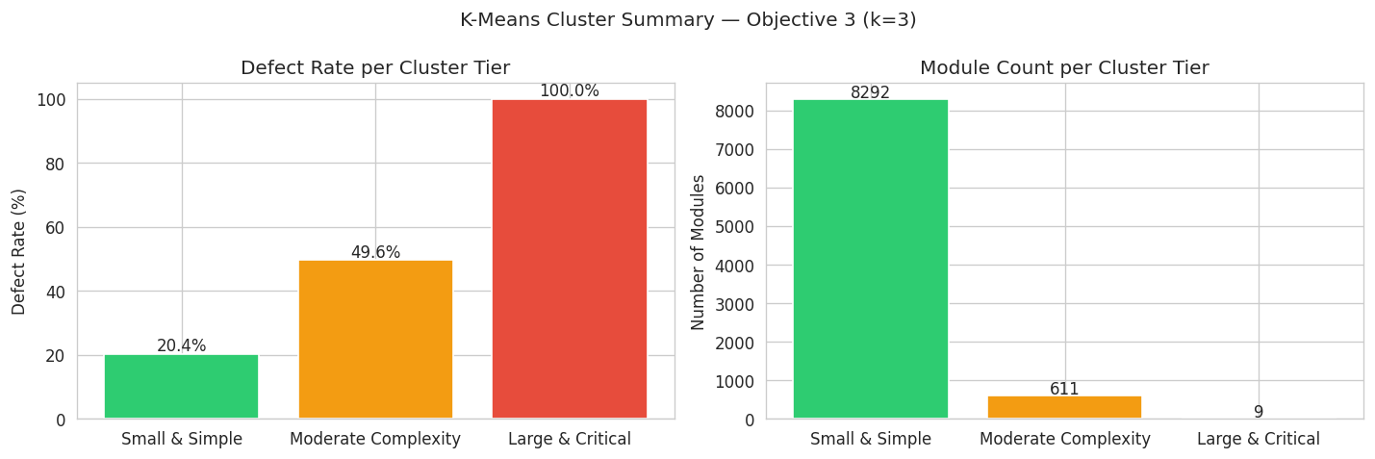
Figure 6. Cluster tier defect rates and module counts.
7. Discussion
Three overarching findings emerge from this study. First, module size, measured by loc and its correlated variants, is the dominant defect predictor across every method applied — feature selection, classification, and clustering all converge on this conclusion. This is consistent with the well-established empirical rule that larger modules have more places for bugs to hide and are more difficult to reason about during review.
Second, cyclomatic complexity v(g) provides independent signal beyond size. Logistic Regression — which captures only linear relationships — ranked it eighth, while both tree-based models ranked it second. This discrepancy indicates that v(g) interacts non-linearly with other features in determining defect proneness; practitioners should not discount it simply because it correlates with LOC.
Third, the modest absolute performance of classifiers (ROC-AUC 0.65–0.69) reflects an inherent ceiling imposed by static metrics alone. Defect occurrence depends on factors beyond structural complexity — programmer experience, review rigour, specification clarity — which are not captured in any static metric suite. Future work combining static metrics with process metrics (change history, developer activity) typically achieves AUC values of 0.80 or higher [6].
8. Limitations
Several limitations should be acknowledged. First, JM1 is a single C-language NASA project; results may not generalise to modern object-oriented codebases. Second, the 1,973 duplicate rows removed from the public release suggest incomplete curation, raising the possibility of additional unlabelled quality issues. Third, static metrics are a necessarily incomplete characterisation of code quality, capturing structural complexity but not semantic correctness, test coverage, or developer intent. Finally, SMOTE introduces synthetic data points that may not reflect real defective-module distributions; this was mitigated by applying SMOTE only to the training partition.
9. Conclusion
This paper presented a complete data-science pipeline for software defect prediction using the NASA PROMISE JM1 dataset. A principled cleaning stage recovered 8,912 unique, type-correct modules from an original file of 10,885 rows. Statistical analysis confirmed that all 21 static code metrics differ significantly between defective and non-defective modules, with lines of code, branch count, and cyclomatic complexity forming a robust top three consensus across four independent feature-selection methods. Classification experiments showed that Random Forest outperforms Logistic Regression and Decision Tree, achieving 74% accuracy and ROC-AUC 0.694 on a fully held-out test set after SMOTE balancing. K-Means clustering with k = 3 revealed three data-driven module tiers with defect rates of 20.4%, 49.6%, and 100% respectively, providing actionable risk profiles for software quality practitioners.
Future work will extend the pipeline with additional classifiers (XGBoost, SVM), cross-project validation on other PROMISE datasets, and incorporation of process metrics such as change frequency and code churn to improve the predictive ceiling.
10. References
[1] T. Menzies, J. Greenwald, and A. Frank, "Data mining static code attributes to learn defect predictors," IEEE Trans. Softw. Eng., vol. 33, no. 1, pp. 2–13, Jan. 2007.
[2] S. Lessmann, B. Baesens, C. Mues, and S. Pietsch, "Benchmarking classification models for software defect prediction: A proposed framework and novel findings," IEEE Trans. Softw. Eng., vol. 34, no. 4, pp. 485–496, Jul. 2008.
[3] M. Shepperd, D. Bowes, and T. Hall, "Researcher bias: The use of machine learning in software defect prediction," IEEE Trans. Softw. Eng., vol. 40, no. 6, pp. 603–616, Jun. 2014.
[4] T. J. McCabe, "A complexity measure," IEEE Trans. Softw. Eng., vol. SE-2, no. 4, pp. 308–320, Dec. 1976.
[5] M. H. Halstead, Elements of Software Science. New York, NY, USA: Elsevier North-Holland, 1977.
[6] R. Malhotra, "A systematic review of machine learning techniques for software fault prediction," Appl. Soft Comput., vol. 27, pp. 504–518, Feb. 2015.
[7] N. E. Fenton and S. L. Pfleeger, Software Metrics: A Rigorous and Practical Approach, 2nd ed. London, UK: International Thomson Computer Press, 1997.
[8] N. V. Chawla, K. W. Bowyer, L. O. Hall, and W. P. Kegelmeyer, "SMOTE: Synthetic minority over-sampling technique," J. Artif. Intell. Res., vol. 16, pp. 321–357, Jun. 2002.
[9] J. Sayyad Shirabad and T. J. Menzies, "The PROMISE Repository of Software Engineering Databases," School of Information Technology and Engineering, University of Ottawa, Canada, 2005.

